1.What is mean by debugging? To monitor the program flow.
2.What are the types of debuggers? Classical, New debugger.
BREAK-POINT. “Session breakpoint, not recommended
BREAK abap38. "external breakpoint.
3.What is mean by break-point? To fix the line to start debugging
4.What are the types of break-point?
Static Fix the break point within program. External - External user, Session - All user.
Dynamic Fix the break point at runtime. External - External user, Session - All user.
5. Use of below function keys?
F5 single step, F6 execute, F7 return, F8 continue.
6.What are the ways to fix break-point? 4 ways to fix break-point
7.How to fix the debugger type predefined?
Utilities -> setting -> debugging
8.While debugging how to move the content externally? Using service of the tools.
9.How to find internal table index? SY-TABIX
10.What is the difference between SY-INDEX and SY-TABIX?
SY-INDEX - To find the iteration no. SY-TABIX – To find internal table index.
11.What is mean by watch point? Conditional breakpoints
12.How to move the cursor previous line?
Choose the line fix break-point -> right click –> go to statement
13.How to fix the break point for specified command?
Break-point –> break point at –> break point at statement.
14.How to fix conditional break point? How we can check more the one condition? Using conditional break point?
Choose the break point –> right click –> create break point condition
In Debug mode -> Click on Break / Watchpoints tab.
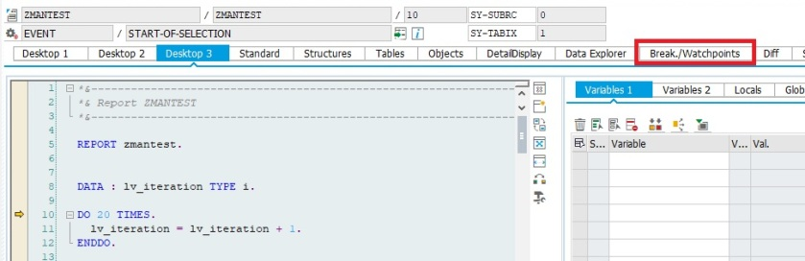
Click on Breakpoints Tab -> Srce Code Tab -> Enter the Row number (Here it is 11, check the above screenshot) -> Enter the condition -> Press OK
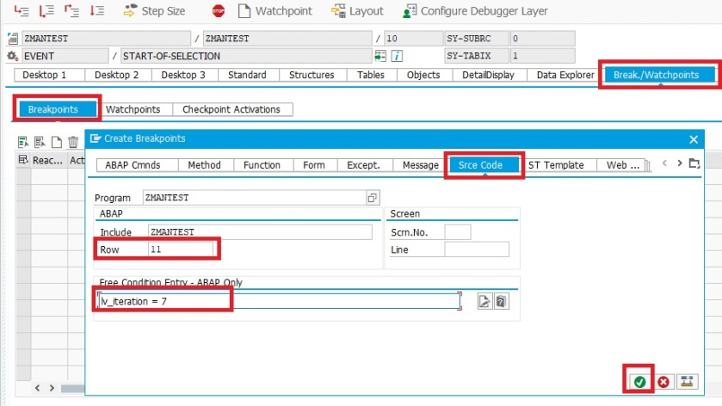
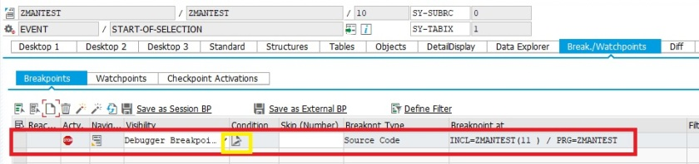
Conditional breakpoint is created. Condition can be changed by clicking on condition icon.
15.What is mean by debug script?
16.What is the difference between classical and new debugger?
Classical debugger
Classic ABAP Debugger runs in the same roll area as the analyzed application. It is therefore displayed in the same window as the application. This functionality is not possible in classic debugger. Script concept not available. No new tool ex: Service of the tools.
New debugger
The new debugger will be executed in its own external window. The new Debugger provides the user with a flexible interface that can be configured as required and has more than eight desktops. New debugger has more than eight desktops and up to four different tools can be displayed at any point of time.Script concept available. New tool exist ex: Service of the tools.
17.How many max breakpoints we can fix in program? 30
18.What is the difference between watch point and conditional break point?
Watch point – Single condition
Conditional break-point – More the one condition

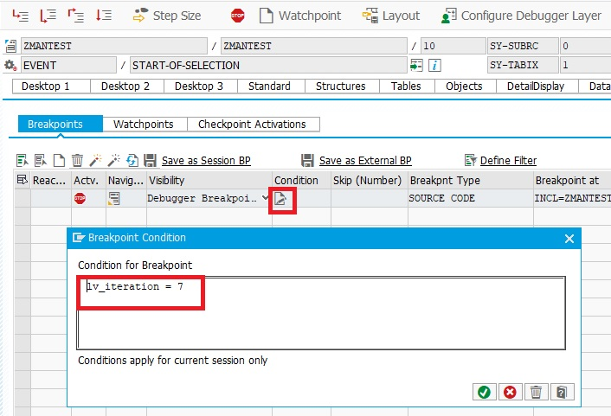
Conditional break point is created in Source code
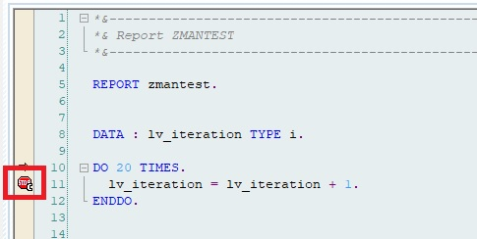
Now after pressing F8, debugger is stopped when value of LV_ITERATION is 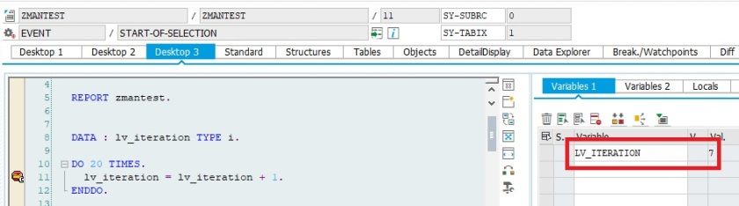
It can also be created by Right Click on break point -> Create break point condition
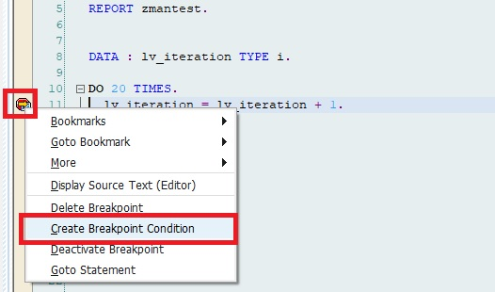
Then provide the condition in the popup.
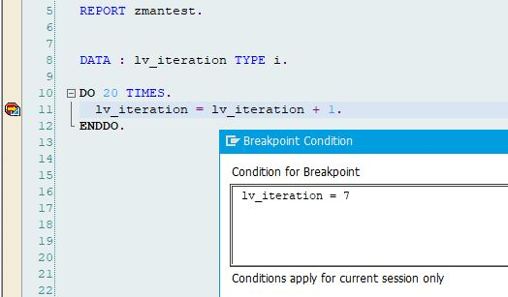
19.How to switch debugger? Debugger -> switched to classical debugger
20.How to debug popup window?
In [function] command type= System command /h

